No. | INSTRUCTIONS |  | KEY POINTS / CONTACTS
1. | Check the reference no. on the portable tools check list for the appliance or power tool. Here you will tick off the checks and fill in any test values which have changed. | 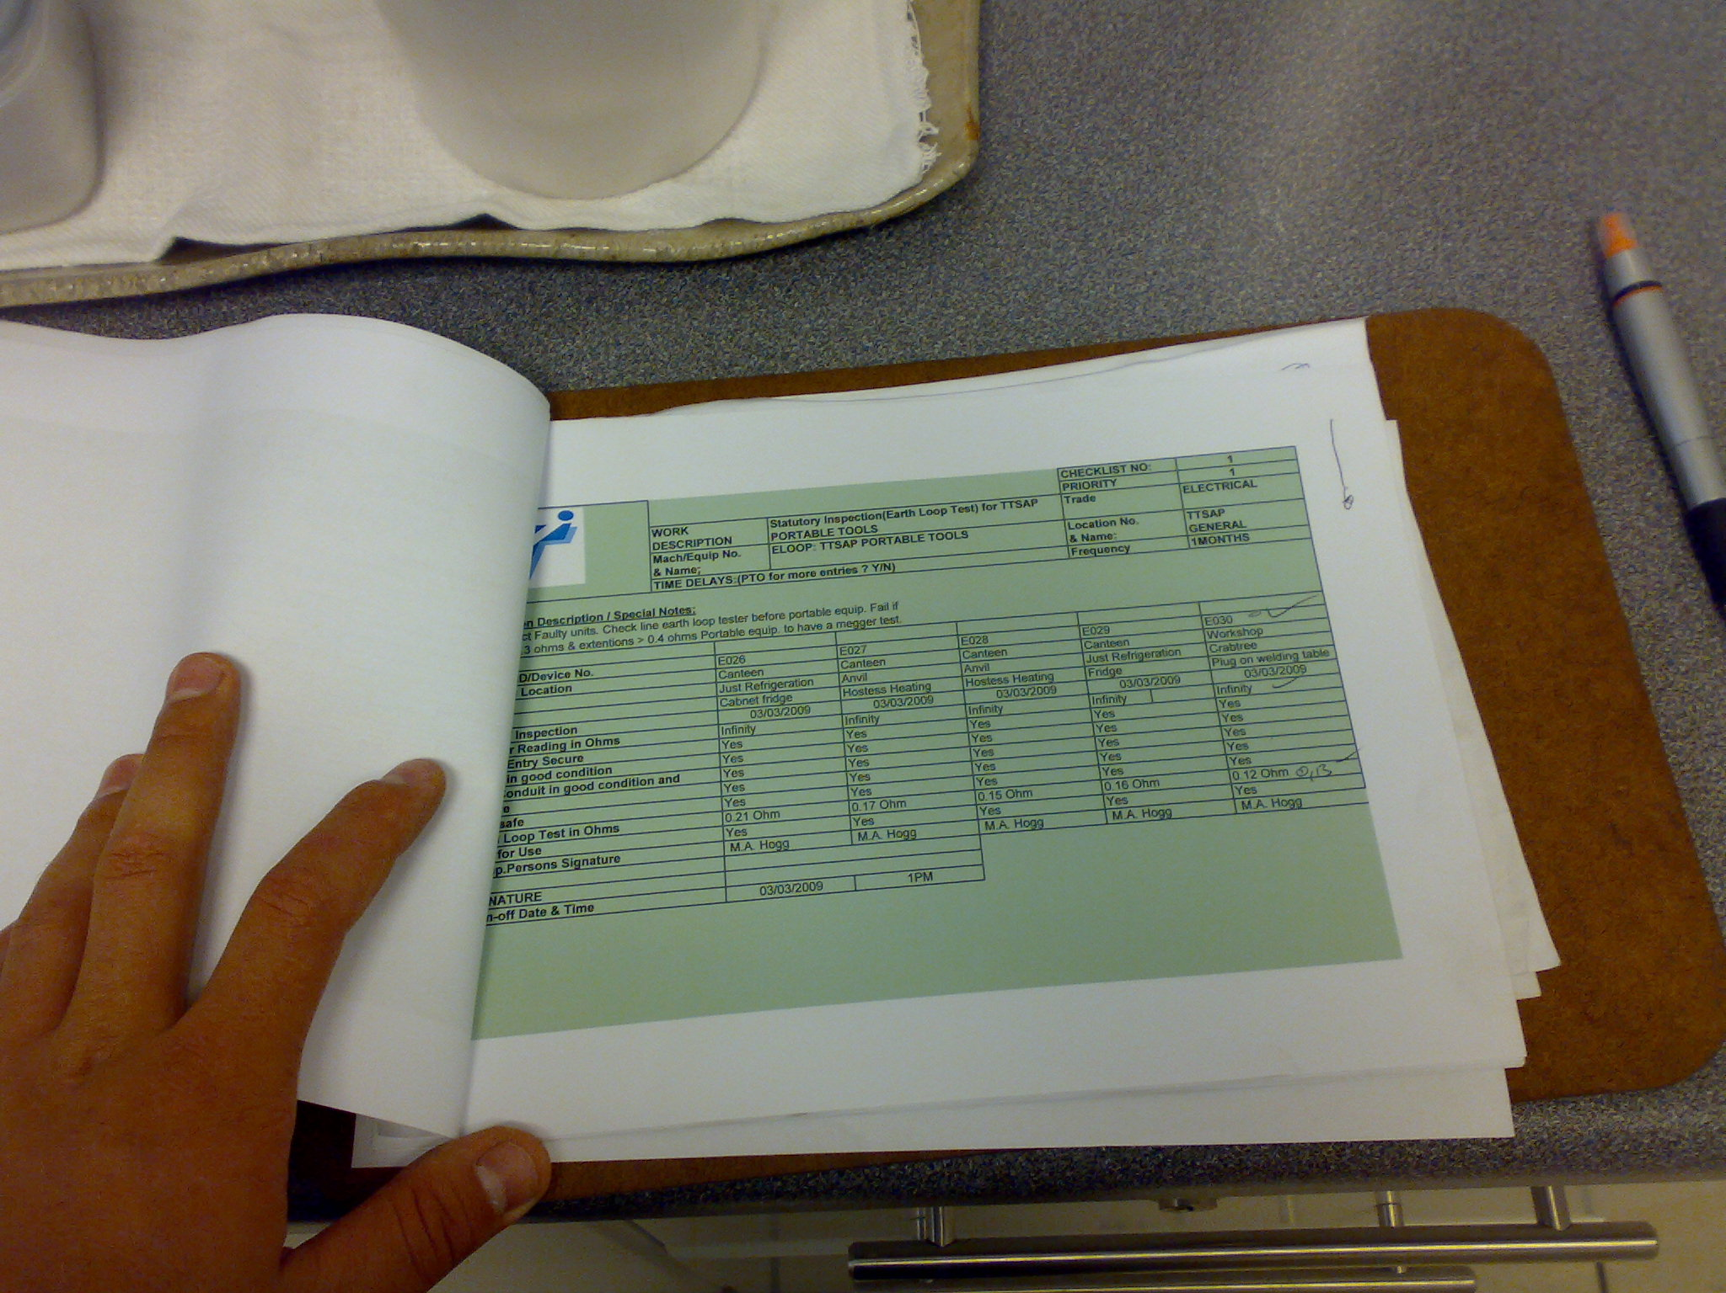 | ENSURE PERSONNAL PROTECTIVE EQUIPMENT (PPE) IS WORN: -  1. HARD HAT  2. STEEL CAP BOOTS  3. GLOVES  ENSURE LOCK- OUTS AND SAFETY BLOCKS ARE USED AT ALL TIMES.
2. | For appliances:  Check visually if the appliance is in good condition including its plug, supply cable and cable entry. | 
3. | Unplug the appliance and do a loop impedance test from the plug to the body. If it is a double insulated appliance this is not necessary. | 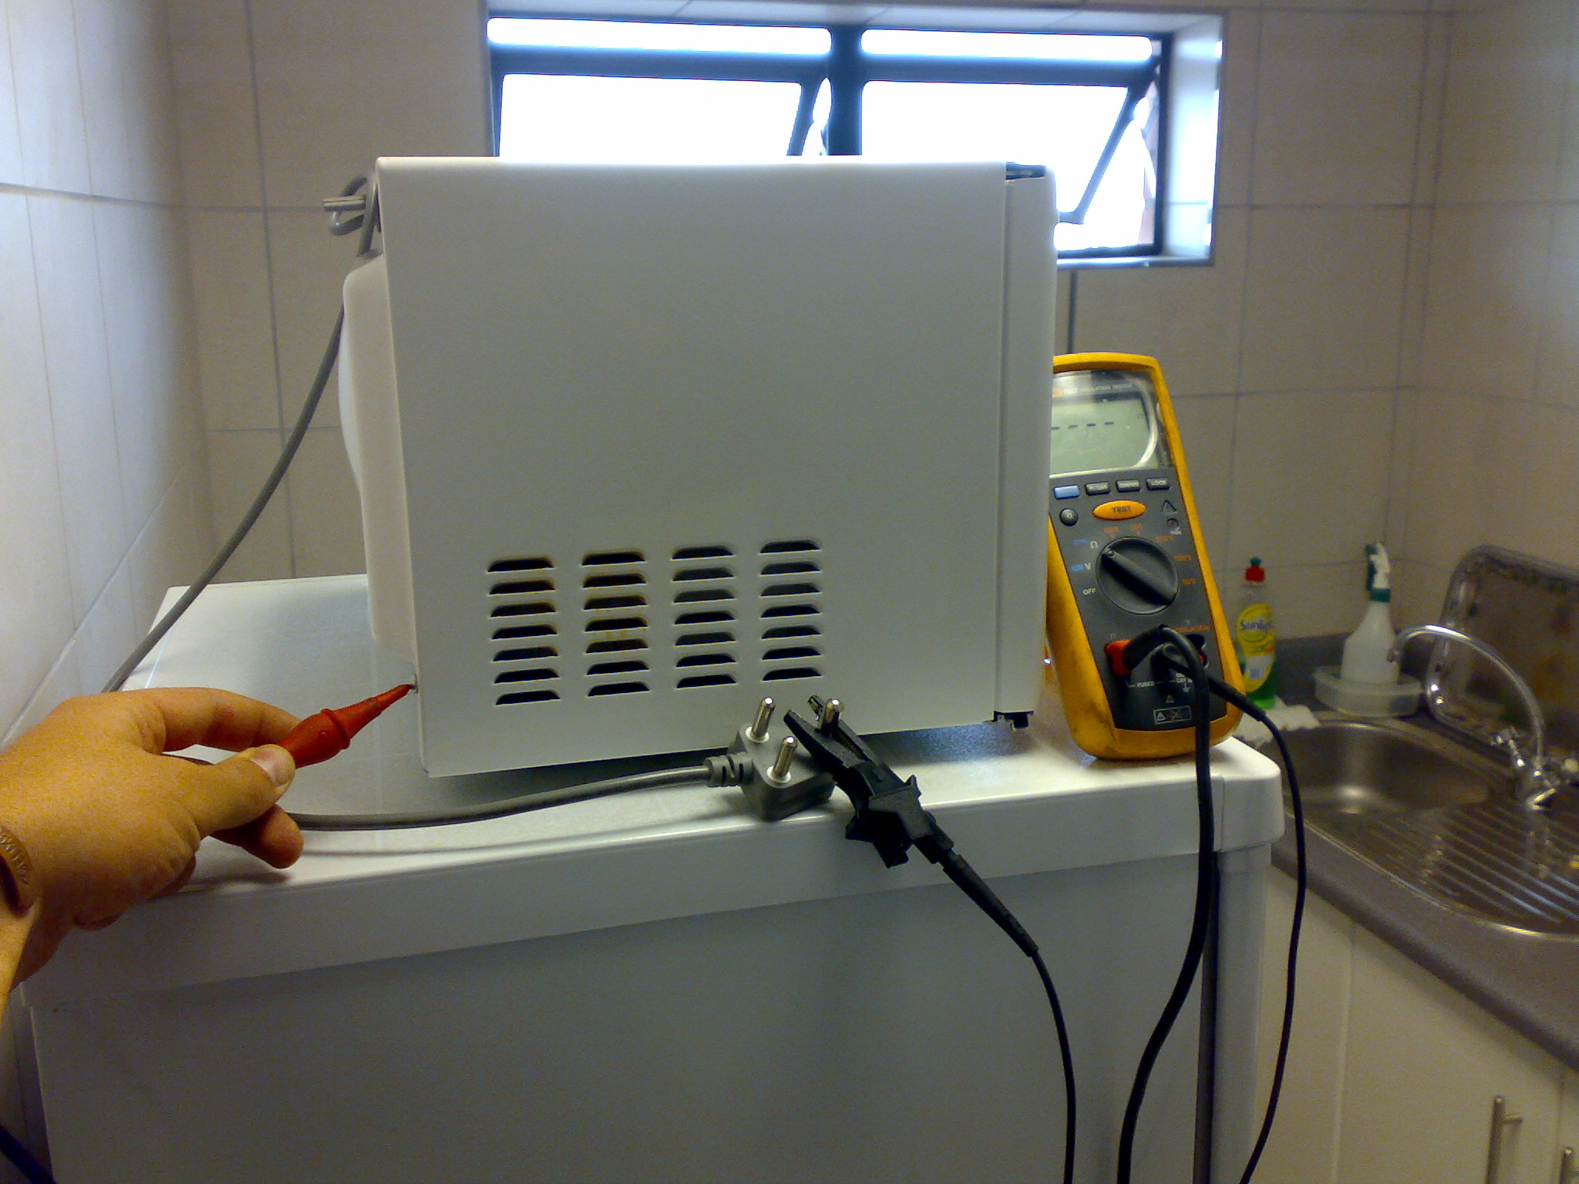
4. | Do an insulation resistance test from earth to live and neutral. | 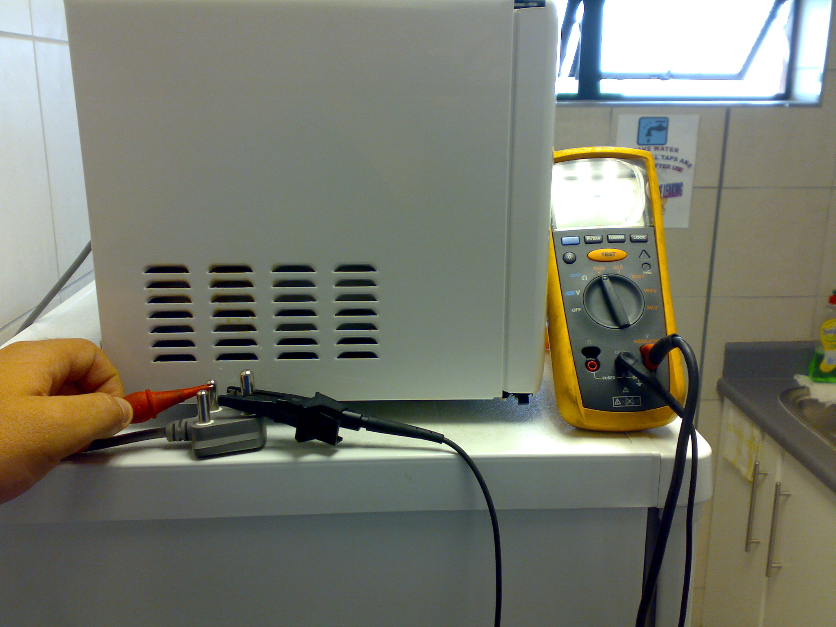
5. | For power tools:  Unplug the power tool and do a loop impedance test from the plug to the body. If it is a double insulated power tool this is not necessary. | 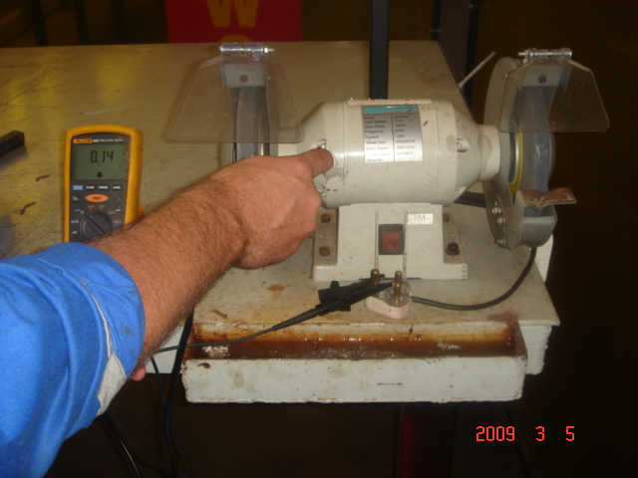
6. | Do an insulation resistance test from earth to live and neutral. | 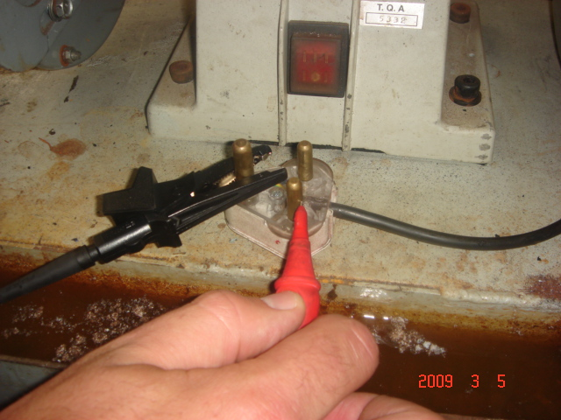
7. | For double insulated tools:  Check visually that the supply cable is in good condition | 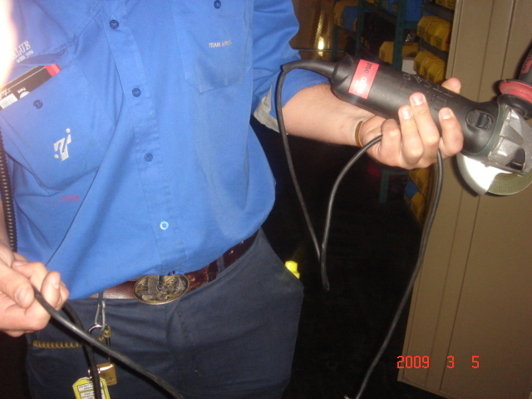
8. | Check visually the cable entry of the power tool is in good condition. | 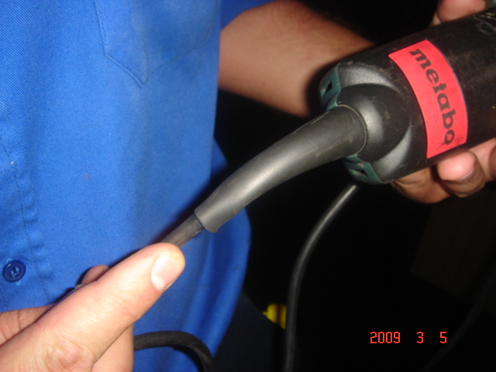
9. | Check the power tool is in good condition. | 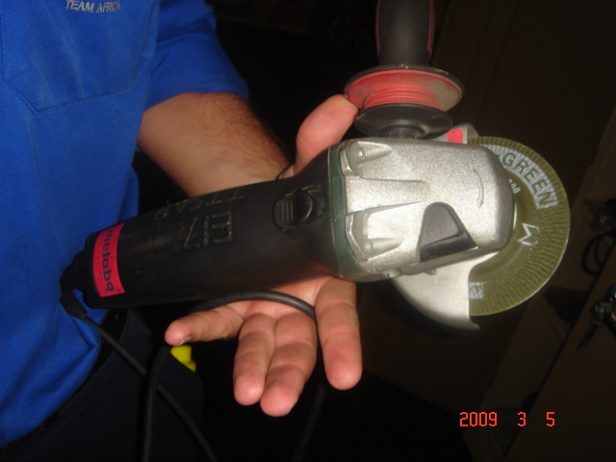
10. | Check the plug is in good condition | 